Low Level Design

Entertainer Analysis

|  |  |
| --- | --- |
| Written by | Author 1 |
| Document Version | 0.1 |
| Last Revised Date |  |

Document Control

Change Record

|  |  |  |  |
| --- | --- | --- | --- |
| Version | Date | Author | Comments |
|  |  |  |  |
|  |  |  |  |
|  |  |  |  |

Reviewer

|  |  |  |  |
| --- | --- | --- | --- |
| Version | Date | Reviewer | Comments |
|  |  |  |  |

Approval Status

|  |  |  |  |  |
| --- | --- | --- | --- | --- |
| Version | Review Date | Reviewed By | Approved by | Comments |
|  |  |  |  |  |
|  |  |  |  |  |

Contents

1. Introduction…………………………………………………………………………………4

1.1 What is low level design document?.............................................4

1.2 Scope…………………………………………………………………………………………4

2.Architecture…………………………………………………………………………………4

3. Architecture Design…………………………………………………………………….6

3.1 Data Description……………………………………………………………………….6

3.2 Data Transformation………………………………………………………………..7

3.3 Data preparation……………………………………………………………………..7

3.4 Data insertion in Power BI……………………………………………………….8

3.5 Deployment…………………………………………………………………………….8-9

4. Unit Test Cases………………………………………………………………………….10

**1.Introduction**

1.1 What is low level design document?

The main aim of the LLD or low level design document is to give the internal logic design of the actual program code for the Analyzing Entertainers dashboard. LLD describes the implementation of the class diagrams with the methods and relations between classes and program specifications so that the code can directly be created from the document itself.

1.2 Scope

Low level design is a component level design process which includes a step by step implementation. This process can be used to create software architecture , data structures and etc. The data organization defined during the requirement analysis and then used in data design.

**2. Architecture**

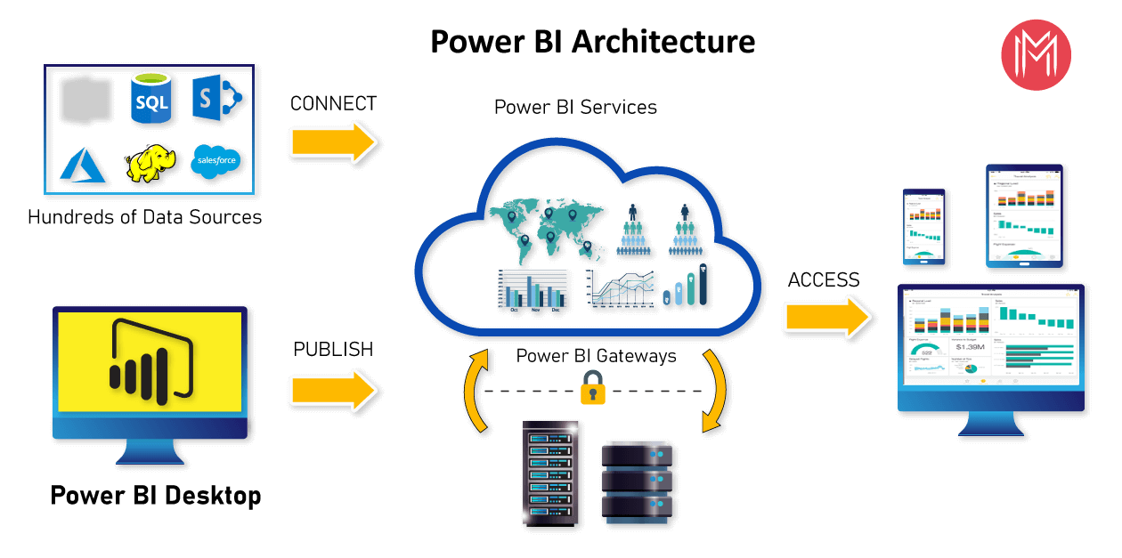

Power BI server Architecture

Power BI architecture is built on Azure. Multiple data sources are supported by Power BI. Power BI desktop is used to create interactive reports and stunning dashboards on the dataset. Power BI gateway is connected to on premises data sources for continuous data for reports and analysis.

Power BI service is the cloud service which is used to publish the reports and dashboards to the web.

Power BI is supported over Android, iOS, windows platforms.

1. Power BI gateway/Connectors:

Power BI gateway is connected to on premises data sources for continuous data for reports and analysis.

2. Power BI service:

Power Bi service is the cloud service which is used to publish the reports and dashboards to the web.

Components of Power BI:

1. Power Query

- Data transformation engine which is used to discover , connect , combine and refine the data.

- Which is used to transform the data.

2. Power Pivot

- Data modelling technique which is used to create models, relationships and to perform calculations.

3. Power view

- available in excel , sharepoint , SQL server and Power BI

-Used to create interactive charts , graphs

- Used to filter data for the visuals

4. Power map

- 3D visualization tool which is used to create map of the data and plot million rows of data visually on Bing maps in 3d format.

- Used to give the latitude , longitude, country , city , state etc.

5. Power BI desktop

- Used for power query , power view , power pivot for developing and driving analysis and insights from the data.

6. Power Q&A

- Used to explore the data

- Used to give more insights from the data.

M formula language:

* The power query is used to filter and combine the data from varied data sources.
* The power query operations are performed by use of M query language.
* It is functional and case sensitive.

**3. Architecture Design**

3.1 Data Description

The dataset contains the data about the Entertainers.

The given dataset contains the columns:

In the dataset of Entertainer Basic Info:

* Entertainer- The name of the Entertainer
* Gender(Traditional)-The Gender of the Entertainer
* Birth Year-The year of Birth of Entertainer.

In the dataset of Entertainer-Breakthrough Info:

* Entertainer- Name of the Entertainer
* Year of Breakthrough/#1 Hit/Award Nomination- The Year of Breakthrough
* Breakthrough Name- The name of the Breakthrough
* Year of First Oscar/Grammy/Emmy- The year of First Oscar

In the dataset of Entertainer- Last Work Info:

* Entertainer- The name of the Entertainer
* Year of Last Major Work(Arguable)- The year of last work done by Entertainers
* Year of Death- the year of death of Entertainers.

In the modified dataset “Entertainments.csv” contains:

* Entertainer- The Name of The Entertainer
* Year of Breakthrough- The year of breakthrough of Entertainers
* Breakthrough Names- The name of the breakthrough
* Year of First Oscar- The year of Oscar of Entertainers
* Gender-The Gender of Entertainers
* Birth year- The birth year of Entertainers
* Year of Last Work – Year of last work done by Entertainers
* Year of Death- Year of Death of Entertainers.

3.2 Data Transformation

The process of data transformation includes:

1. Converting data types

2. Removing columns

3. Creating columns

4. Filtering null values

5. Filtering missing values

6. Removing unwanted data

7. Renaming Columns

3.3 Data Preparation

Creating another column for calculating the Age from the column Birth year and Year of Death

Using the formula: Age= Year of Death – Birth Year

Converting the data types of Birth year , Year of Death year , year of Last Work , Year of First Oscar, Year of Breakthrough to date/time hierarchy.

Removing unwanted rows from the dataset and filtering null values.

3.4 Data insertion in Power BI

Step1: Configuring Power BI

Launch Power BI application when downloaded , and then the pop up dialogue box will appear which will ask for get the data. Click on get the data , it will ask you to select the source of data from the list of options like text/CSV, web , excel and etc.

In this case , the dataset is in the format of CSV, load the dataset and make the transformations further and apply the changes.

The window will look like this:

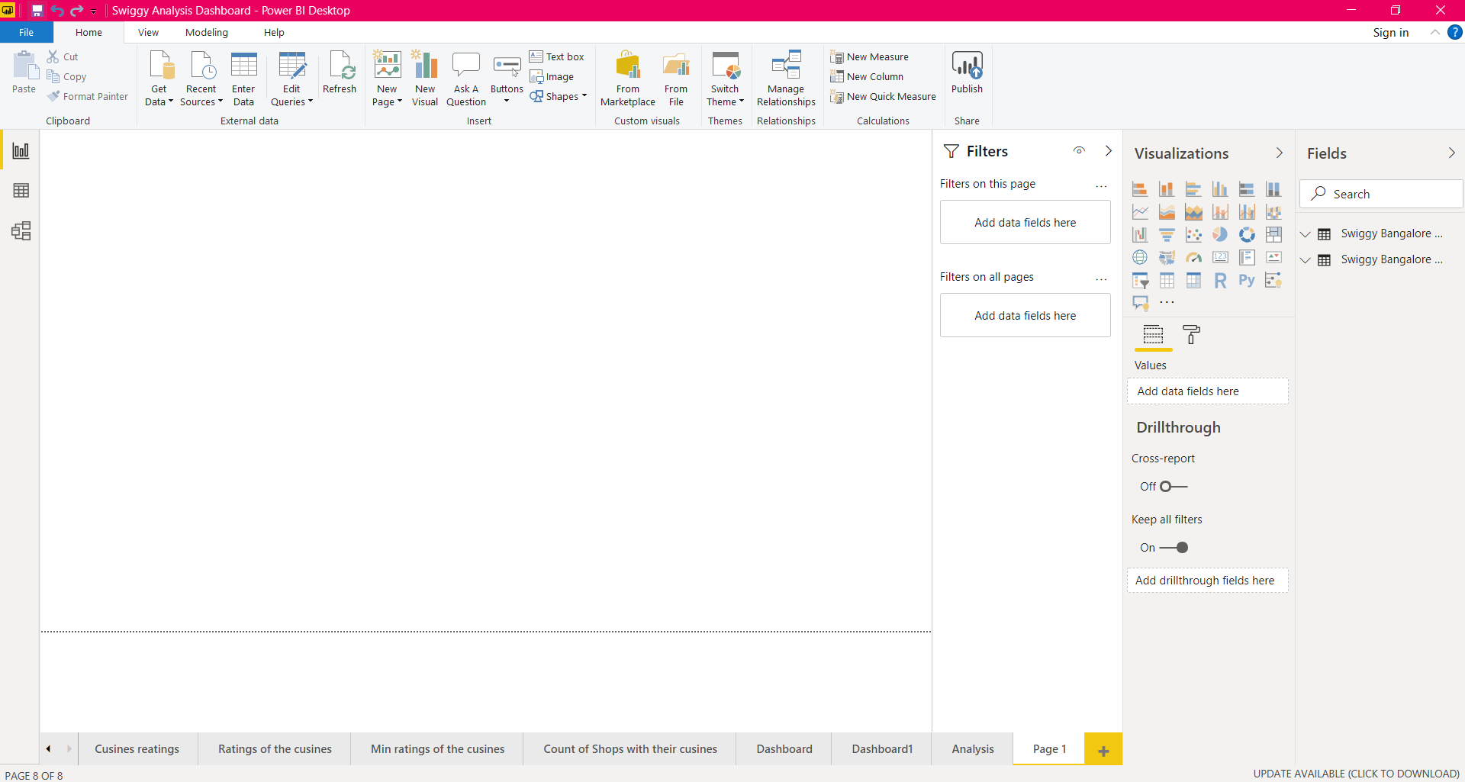

The reports and dashboards can be shared as file and saved as a power bi file in .pbix format.

3.5 Deployment

The reports and dashboards can be published on web using Power BI

Service. The Power BI service asks for work email or the pro license/ premium license of individual to login and publish on the web.

Or else, the file can be saved in the form of .pbix format and can be shared across the platforms.

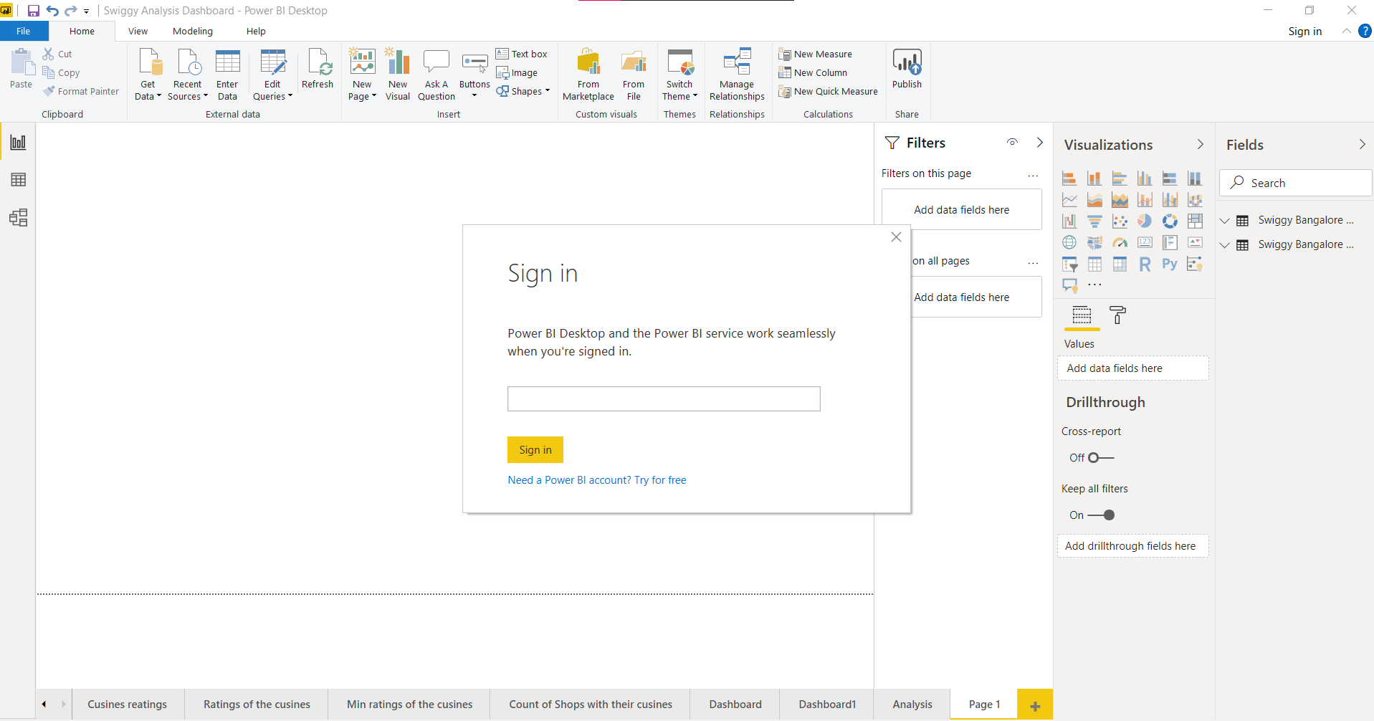

**4. Unit Test Cases**

|  |  |
| --- | --- |
| Test case description | Expected results |
| Entertainer parameter filter | It will give the dropdown list for making changes in the ages, birth year, Gender of Entertainers |
| Entertainer parameter filter | It will give the dropdown list of for making changes in the ages, death year, gender of Entertainers |
| Entertainer filter | It will give the dropdown list of the Entertainers for making changes in the Oscar year and other parameters. |
| Entertainer slicer | The slicer will list out the Entertainers for making changes in the breakthrough names , ages and other measures. |